**Project Design Phase-II Technology Stack (Architecture & Stack)**

|  |  |
| --- | --- |
| Date | 23 October 2022 |
| Team ID | PNT2022TMID48661 |
| Project Name | Smart Farmer – IOT Enabled Smart Farming Application |
| Maximum Marks | 4 Marks |

**DOMAIN :** IoT

**Project Title:** Smart Farmer – IOT Enabled Smart Farming Application

Team Members:

1)Balaji M (920819106008)

2)Harishwar S (920819106019)

3)Kishore Krishnaa J (920819106026)

4)Kirthick N (920819106025)

**Technical Architecture:**

The Deliverable shall include the architectural diagram as below and the information as per the table1 & table 2

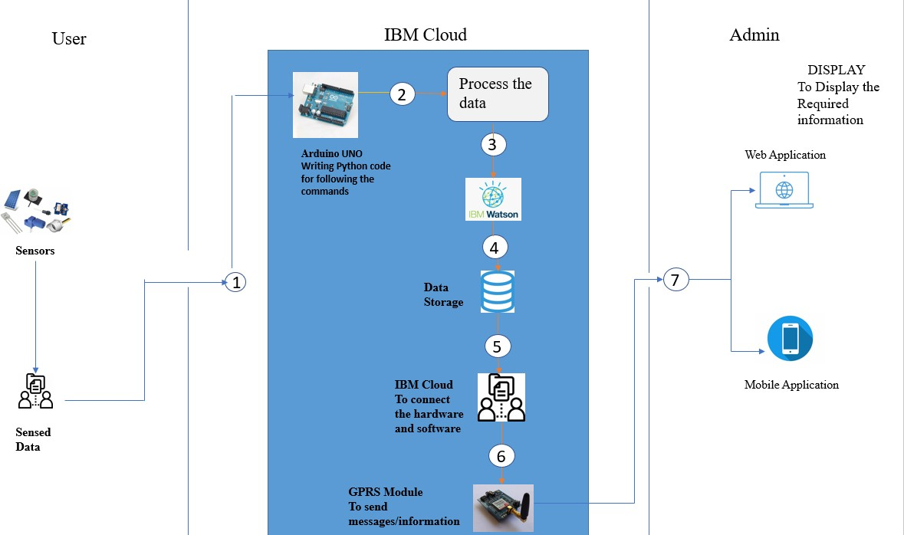

Guidelines:

1. Include all the processes (As an application logic / Technology Block)
2. Provide infrastructural demarcation (Local / Cloud)
3. Indicate external interfaces

(third party API’s etc.)

1. Indicate Data Storage components / services
2. Indicate interface to machine learning models (if applicable)

# Table-1 : Components & Technologies:

|  |  |  |  |
| --- | --- | --- | --- |
| **S.No** | **Component** | **Description** | **Technology** |
| 1. | User Interface | Through Mobile app or Web Application the information processed will be sent to the user  through message or mail. | HTML, CSS, JavaScript / Angular Js / React Js etc. |
| 2. | Application Logic-1 | The code will include certain conditions like based on the humidity condition the water flow will be controlled, based on the moisture content the water flow will be controlled and if the temperature exceeds certain level it will also be intimated  through message and mail. | Java / Python |
| 3. | Application Logic-2 | Here we can develop the software process like  creating a device and then adding Node RED to form as an interface. | IBM Watson STT service |
| 4. | Application Logic-3 | Here the sensed data and the conditions can be checked and the final result can be obtained. | IBM Watson Assistant |
| 5. | Database | We can save all the data in SQL or any other  database so that the user can retrieve data whenever required. | MySQL, NoSQL, etc. |
| 6. | Cloud Database | The database we created and the predefined data’s like weather from external API can be combined here and can be stored safely with  security for future purpose. | IBM DB2, IBM Cloudant etc. |
| 7. | File Storage | File storage requirements | IBM Block Storage or Other Storage Service or Local Filesystem |
| 8. | External API-1 | With the help of external API only we can know the weather condition and compare with our sensed  inputs. | IBM Weather API, etc. |
| 9. | External API-2 | Purpose of External API used in the application | Aadhar API, etc. |
| 10. | Machine Learning Model | Purpose of Machine Learning Model | Object Recognition Model, etc. |
| 11. | Infrastructure (Server / Cloud) | Application Deployment on Local System / Cloud Local Server Configuration: Through our ideas  Cloud Server Configuration : Through IBM | Local, Cloud Foundry, Kubernetes, etc. |

**Table-2: Application Characteristics:**

|  |  |  |  |
| --- | --- | --- | --- |
| **S.No** | **Characteristics** | **Description** | **Technology** |
| 1. | Open-Source Frameworks | MIT App Inventor, Python, Weather App API. | Technology of Opensource framework |
| 2. | Security Implementations | Here we are using IBM Cloud and it is the very  secured place where we can store the data and retrieve the information whenever needed. | IBM Cloud, MIT App Invertor , IBM Watson Assistant |
| 3. | Scalable Architecture | Cloud-based IoT is becoming an increasingly popular and desirable solution. This work presents a specially designed architecture based on IBM Cloud services for monitoring livestock using Internet of things (IoT) equipment and a wide range of cloud native services. Used services in IBM a stress test to prove the ability of  the developed architecture for data processing was completed | IBM Cloud |
| 4. | Availability | Many important features are available in this application instead of wasting time by staying in the farm and monitoring the conditions we have the moisture, humidity and temperature which will denote the corresponding quantities and we have both automatic and manual mode so once the certain conditions are met pump will be on/off and messages will be sent when needed so the farmer  just have to check the message in their phone and can take decisions accordingly. | Sensor Networks , IBM Watson IoT , IBM Cloud , Weather API’S , Analytics |
| 5. | Performance | **Excelled efficiency**: Today’s agriculture is in a race. Farmers have to grow more products in deteriorating soil, declining land availability and increasing weather fluctuation. IoT-enabled agriculture allows farmers to monitor their product and conditions in real-time. They get insights fast, can predict issues before they happen and make informed decisions on how to avoid them.  Additionally, IoT solutions in agriculture introduce | Sensor Networks , IBM Watson IoT , IBM Cloud , Weather API’S , Analytics |

|  |  |  |  |
| --- | --- | --- | --- |
| **S.No** | **Characteristics** | **Description** | **Technology** |
|  |  | automation, for example, demand-based irrigation, fertilizing and robot harvesting.  **Expansion:-**By the time we have 9 billion people on the planet, 70% of them will live in urban areas. IoT-based greenhouses and hydroponic systems enable short food supply chains and should be able to feed the people. Smart closed-cycle agricultural systems allow growing food basically everywhere—in supermarkets, on skyscrapers’ walls and rooftops, in shipping containers and, of course, in the comfort of everyone’s home.  **Reduced resources:** Plenty of agriculture IoT solutions are focused on optimizing the use of resources—water, energy, land. Precision farming using IoT relies on the data collected from diverse sensors in the field which helps farmers accurately allocate just enough resources to within one plant. **Cleaner process**: Not only do IoT-based systems for precision farming help producers save water and energy and, thus, make farming greener, but also significantly scale down on the use of pesticides and fertilizer. This approach allows getting a cleaner and more organic final product compared to traditional agricultural methods.  **Agility:** One of the benefits of using IoT in agriculture is the increased agility of the processes. In the conditions of extreme weather changes, new capabilities help agriculture professionals save the crops.  **Improved product quality:** Data-driven agriculture helps both grow more and better products. Using soil and crop sensors, aerial drone monitoring and farm mapping, farmers better  understand detailed dependencies between the |  |

|  |  |  |  |
| --- | --- | --- | --- |
| **S.No** | **Characteristics** | **Description** | **Technology** |
|  |  | conditions and the quality of the crops. Using connected systems, they can recreate the best conditions and increase the nutritional value of the products.  As a result, all of these factors can eventually lead to higher revenue. |  |

**References:**

[**https://c4model.com/**](https://c4model.com/)

[**https://developer.ibm.com/patterns/online-order-processing-system-during-pandemic/**](https://developer.ibm.com/patterns/online-order-processing-system-during-pandemic/)[**https://www.ibm.com/cloud/architecture**](https://www.ibm.com/cloud/architecture)

[**https://aws.amazon.com/architecture**](https://aws.amazon.com/architecture)

[**https://medium.com/the-internal-startup/how-to-draw-useful-technical-architecture-diagrams-2d20c9fda90d**](https://medium.com/the-internal-startup/how-to-draw-useful-technical-architecture-diagrams-2d20c9fda90d)